**Apache Commons Codec**

This document summarizes the steps involved in generating the bug reports and calculating the Backlog Management Index of different Apache Commons Codec. Most of the Apache projects have their own issue tracking systems – JIRA. The link to these JIRA pages can be found in the GitHub repository of the projects itself. The various steps involved in the issue tracking for this project is summarized below.

1. Open the GitHub repository

<https://github.com/apache/commons-codec>

1. Scroll to the bottom of the page to Additional Resources.
2. Click on Apache Issue Tracker (JIRA) to open the JIRA page.

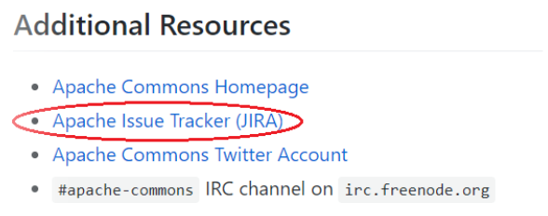

1. Navigate to the leftmost menu of the JIRA page.
2. Click on *Reports*.

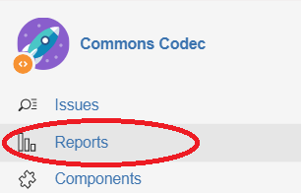

1. In the reports page, there are a different options through which we can calculate or view different metrics of the project. For this project, we will be requiring the number of issues/bugs created and resolved. So, we will be using the *Created vs Resolved Issues Report.*

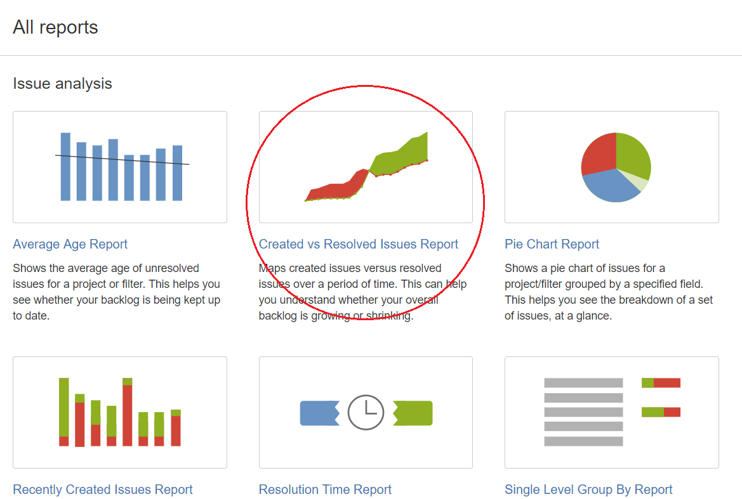

1. Now, we will need to configure the report as per our requirement. For the demonstration purposes, we will be viewing the monthly bug report for the last year i.e., from June 2018 to May 2019. So, we will be entering the number of days as 365.

We can configure the report as per the below image:

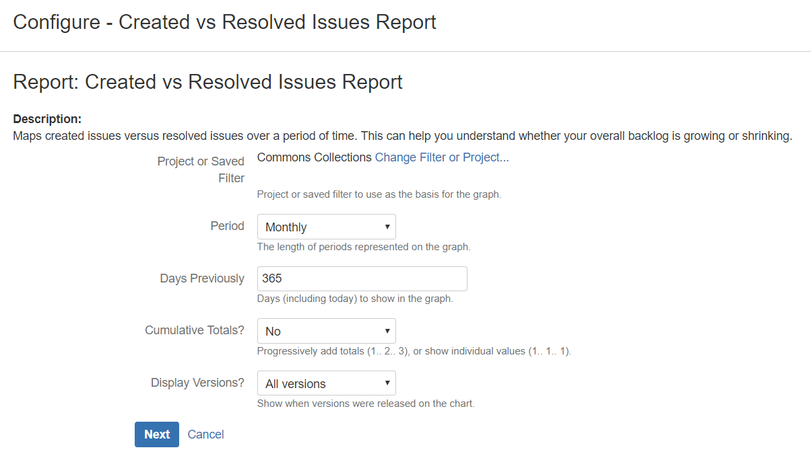

1. After clicking on *Next,* we will get the bug report as follows:

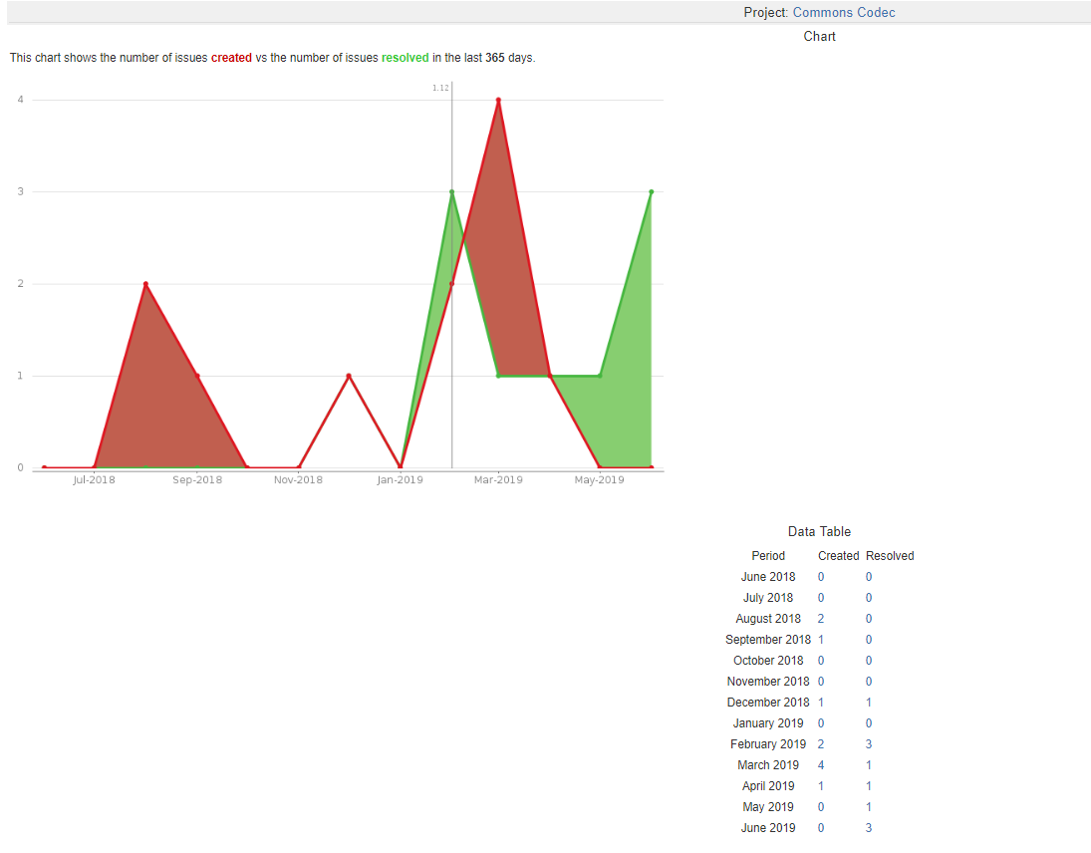

1. Using the tabulated data, we can calculate the BMI for the month of March 2019.

**BMI = Number of problems closed during the month X 100% = (1/4)*100% = 25%**

**Number of problem arrivals during the month**

Similarly, we can calculate the BMI for the last 12 months as seen in the table below.

|  |  |  |  |  |  |
| --- | --- | --- | --- | --- | --- |
| **Apache Commons Codec** | | | | | |
| **Month** | **Issues Arrived** | **Issues Closed** | **BMI (%)** | |
| Jun-18 | 7 | 5 | | 71.43 | |
| Jul-18 | 6 | 5 | | 83.33 | |
| Aug-18 | 0 | 0 | | 0 | |
| Sep-18 | 3 | 0 | | 0 | |
| Oct-18 | 5 | 1 | | 20 | |
| Nov-18 | 5 | 2 | | 40 | |
| Dec-18 | 1 | 3 | | 300 | |
| Jan-19 | 2 | 3 | | 150 | |
| Feb-19 | 1 | 1 | | 100 | |
| Mar-19 | 1 | 0 | | 0 | |
| Apr-19 | 2 | 1 | | 50 | |
| May-19 | 4 | 2 | | 50 | |

As we can see the value of BMI for December 2018 is greater than 100% which indicates that the backlog is reduced.